LIFE-CYCLE THINKING AND CIRCULARITY
- SUMMARY FACTSHEET
Thematic Area | MAIN TOPIC
Short technical description
Life-cycle thinking applies systemic analysis of resource use across the entire lifespan of products, buildings, and infrastructure. The aim is to minimise environmental impact by reducing embodied energy, reusing components, and recycling materials. Circularity in cities shifts from the traditional “take–make–dispose” model toward closed loops, where waste becomes input for new processes. This action includes conducting Life-Cycle Assessment (LCA) studies in line with ISO 14040/44 standards, identifying hotspots of emissions or resource depletion, and prioritising design-for-reuse strategies.
In practice, the technical action involves:
- LCA modelling using tools such as SimaPro, GaBi, or OpenLCA to quantify embodied energy and carbon in construction and mobility systems.
- Material passports and digital twins, which track components for future reuse in urban renovation.
- Recycling and reuse schemes, ensuring secondary materials (steel, concrete, plastics, electronic waste) re-enter the economy at high value.
Cities adopting circular strategies benefit from lower material demand (up to 30–40% reductions in construction), reduced landfill pressure, and alignment with the EU Circular Economy Action Plan. When applied to buildings and infrastructure, circularity also enables long-term cost savings through material recovery and reduced environmental liabilities.

Technical diagram
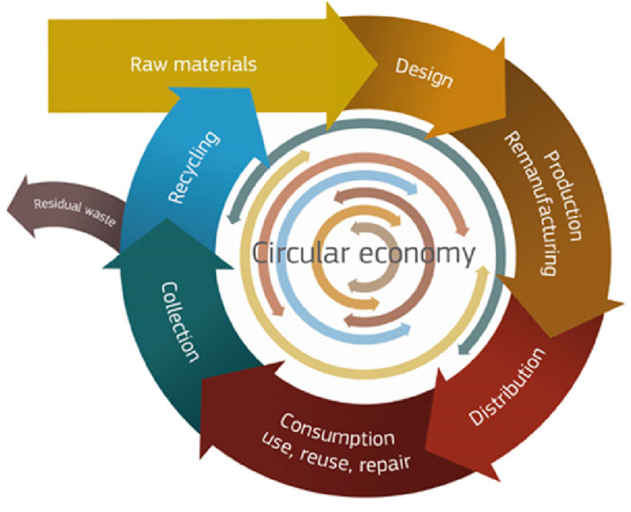

- TECHNICAL KNOWLEDGE

Phases of implementation
P1 | Assessment & Goal Definition
P1.1 |  |  | Assessment & Goal Definition Determine the objectives (e.g., reducing embodied energy, prioritising recyclability).
P1.2 |  |  | Data Inventory (LCI): Collect input/output data on energy use, emissions, raw material extraction, and waste.
P1.3 |  |  | Hotspot Identification: Identify processes or life-cycle stages with the highest environmental burdens.
P2 | Planning & Strategy Design
P2.1 |  | Planning & Strategy Design Test strategies such as reuse, remanufacturing, or material substitution.
P2.2 |  | Circular Design Integration: Apply eco-design principles, considering disassembly, modularity, and recyclability.
P3 | Implementation & Monitoring
P3.1 |  |  | Pilot Actions: Implement demonstration projects (e.g., recycled concrete use, urban wood recovery).
P3.2 |  |  | Stakeholder Engagement: Train municipalities, contractors, and citizens on recycling/reuse practices.
P3.3 |  |  | Monitoring & Reporting: Use LCA-based indicators to track environmental performance (CO₂, resource use).

- KNOWLEDGE RECOMMENDATIONS
RECOMMENDATIONS
General Recommendations

LCA should be embedded as a decision-support tool from the earliest stages of planning. Cities should adopt a cradle-to-cradle perspective, ensuring that design, construction, operation, and end-of-life are systematically evaluated. The use of standardised methodologies (ISO 14040/44, EN 15804 for construction products, and Product Environmental Footprint guidance from the EU) is essential to guarantee comparability and credibility. Municipalities should also create material passports and digital databases that make life-cycle information accessible across stakeholders.

Potential Challenges

Implementation may face challenges such as data gaps, limited local expertise, or high costs of LCA software and consultancy. Small municipalities often lack the institutional capacity to collect and update inventory data, while construction companies may resist transparency due to perceived risks of disclosing environmental burdens. Complexity of supply chains can also make it difficult to assess recycling and reuse potential reliably.

Adaptation Across Cities

To succeed across different contexts, actions should be adapted to local conditions:

In resource-constrained cities, simplified or sectoral LCAs (e.g., building materials, waste streams) can be used as a first step.

In larger cities, comprehensive LCA combined with circular procurement policies can drive markets for low-impact materials.

For cities with a strong industrial base, collaboration with local industry and universities can improve data quality and open opportunities for industrial symbiosis (sharing by-products and waste streams).

For citizens, awareness campaigns should translate LCA results into simple indicators (carbon footprint per m², water footprint per product) to make the concept tangible.

- SCORING
.
Difficulty level  ☼ ☼ ☼ ☼ ☼ | Cost of implementation  € € € € €
Enviromental impact  ♠ ♠ ♠ ♠ ♠ | Social acceptance  ☺ ☺ ☺ ☺ ☺

- COMPLETE FACHTSHEET
Thematic Area | MAIN TOPIC
DESCRIPTION
Technical description
Introduction

Life-cycle thinking looks at the entire life of a building or urban asset—from raw material extraction to manufacturing, transport, construction, use, maintenance, and end-of-life. Instead of focusing only on energy in operation, it measures embodied impacts (materials, manufacturing, transport, construction processes) and end-of-life outcomes (demolition, landfill, recycling, or reuse). Circularity then acts on those insights: it changes how we design, procure, build, operate, and deconstruct so that materials remain in use at their highest value for as long as possible.

This action equips cities and project teams to quantify impacts with Life-Cycle Assessment (LCA) and to intervene with circular strategies such as design for disassembly (DfD), high-value reuse, urban mining, and materials passports. The result is lower embodied greenhouse-gas emissions, fewer extraction impacts, less waste, and better resilience to supply-chain shocks.

Objectives

Quantify environmental impacts across the full life cycle (carbon, resource use, water, waste), using recognised standards (e.g., ISO 14040/14044, EN 15978, EN 15804 for Environmental Product Declarations—EPDs).

Reduce embodied carbon and resource demand by selecting low-impact materials, reusing components, and specifying products with robust, verified EPDs.

Enable future reuse through DfD, standardized fixings, modular systems, and clear documentation (e.g., materials passports).

Close material loops with selective demolition/deconstruction, on-site sorting, certified reuse, and urban mining partnerships.

Integrate LCA and circularity into procurement, permits, and contracts so that outcomes are measurable and enforceable.

Technical Scope and Standards

LCA follows a clear methodology so results are comparable and defensible.

Functional Unit (FU): for buildings, typical FU is 1 m² of Gross Floor Area over a reference study period (e.g., 50–60 years).

System Boundaries: per EN 15978, cover modules A1–A3 (product stage, including raw materials and manufacturing), A4–A5 (transport to site, construction/installation), B1–B7 (use stage, including maintenance, repair, replacements, energy and water in use), C1–C4 (end-of-life), and D (benefits and loads beyond system boundary—e.g., credited benefits from reuse/recycling).

Data Sources: use EN 15804-compliant EPDs for products when available; complement with quality-assured generic datasets where needed. Track data quality (representativeness, age, completeness, uncertainty).

Impact Indicators: at minimum Global Warming Potential (GWP); where relevant add Resource Use, Acidification, Eutrophication, Photochemical Ozone Formation, Water Use, and Waste.

Frameworks & Tools: align with EU Level(s) indicators for design and public reporting. Typical software: One Click LCA, SimaPro, GaBi, OpenLCA.

Workflow and Responsibilities
1) Early Design — “Quantify first, decide early”

Screening LCA: run a quick model during concept design to identify hotspots (e.g., structural frame, façade, insulation, MEP).

Optioneering: compare alternatives such as low-carbon concrete mixes, timber or hybrid structures, high-recycled-content steel, or lightweight assemblies that reduce material mass.

DfD Principles: select reversible connections (bolts, screws), accessible fixings, standardised modules, and layer separation (structure, services, finishes) to enable disassembly and replacement.

Specification: require EPDs and declare repairability, reusability, and recycled content in tenders.

2) Detailed Design & Procurement — “Make it contractual”

Performance Targets: include embodied-carbon limits (e.g., kgCO₂e/m² by element or whole building) and minimum recycled content requirements in procurement documents.

Materials Passport: prepare a bill of materials with IDs, quantities, and documentation to support future reuse.

Supplier Engagement: pre-qualify vendors providing EN 15804 EPDs, take-back schemes, and component leasing where appropriate (carpets, luminaires, façades).

3) Construction — “Build for disassembly, track materials”

Selective Construction & QA: verify declared product EPDs, batch numbers, and installation methods that preserve disassembly potential.

On-site Waste Management: sort by high-value fractions (metals, timber, clean concrete, plasterboard); protect reusable offcuts/components.

Digital Tracking: update the materials passport with as-built quantities and locations (QR/BIM link).

4) Use & Maintenance — “Keep value high”

Planned Maintenance: choose replacement cycles that extend component life (e.g., re-laminating, re-finishing).

Minor Works Protocols: require that small refurbishments preserve DfD and update the materials passport.

Monitoring: periodic LCA updates when major refurbishments occur; track waste diversion and reused content over time.

5) End-of-Life / Next Use — “Mine the city”

Pre-demolition Audits: map reusable elements (doors, radiators, beams, façade cassettes) and recyclable streams.

Deconstruction Plans: prefer sequenced disassembly over demolition; schedule reverse logistics to reuse hubs or digital marketplaces.

Module D Accounting: document credits from reuse/recycling to show net life-cycle benefits.

Circular Design & Intervention Catalogue (what to do in practice)

Structure: cement-reduced concretes, high-recycled steel, timber/hybrid systems; standard spans and bolt-on secondary structures.

Envelope: demountable façades (cassette systems), removable rainscreens, mechanical fixings, replaceable insulation layers.

Interiors: modular partitions, flooring and ceiling systems designed for lift-and-reuse; leased carpet tiles with take-back.

MEP: accessible service corridors, plug-and-play components, product-as-a-service models (e.g., luminaires, batteries).

Public realm: prefabricated elements, reused pavers/street furniture, reversible foundations for temporary uses.

KPIs and Verification

Embodied GWP (A1–A3, A4–A5, B, C, D): kgCO₂e/m² for key elements and whole asset.

Reused/Recovered Content: % of components reused or % recycled content by mass and by value.

Waste Diversion: % construction and demolition waste diverted from landfill; hazardous waste handled per regulation.

Design for Disassembly Score: qualitative checklist (reversible fixings, access to connections, modularity, documentation).

Data Quality: share of product quantities covered by 3rd-party EPDs vs generic datasets.

Technical Risks and How We Manage Them

Data gaps or inconsistent EPDs: mitigate with supplier engagement, documented assumptions, and sensitivity analysis.

Design lock-in: start LCA very early to avoid “too late to change” decisions.

Cost concerns: apply total cost of ownership thinking (resale value of components, avoided landfill, reduced new material purchases).

Quality/Compliance: require third-party critical review for public claims and align with Level(s) reporting for comparability.

Integration with City Policy & Procurement

Planning & Permits: require screening LCA at concept stage and detailed LCA at building permit.

Public Procurement: include embodied-carbon thresholds, EPD coverage requirements, and DfD criteria in tender scoring.

Deconstruction Bylaws: mandate pre-demolition audits and deconstruction for suitable assets; set reuse quotas for municipal works.

City Platforms: support reuse hubs and digital marketplaces to connect deconstruction sites with designers and contractors.

Expected Benefits

Adopting life-cycle thinking and circular practices cuts embodied carbon and reduces virgin-material demand. Projects typically see meaningful double-digit percentage reductions in embodied GWP when circular options are chosen early, alongside significant waste diversion during construction and end-of-life. Documentation (materials passports, Level(s) reporting) makes these gains visible, auditable, and replicable across the municipal portfolio.

Visual Information

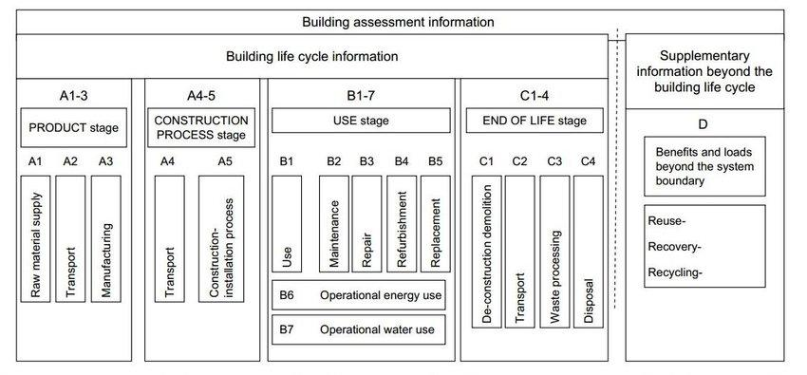
Figura 5 Building LCA stages according to EN-15978
– Life-Cycle Stages (EN 15978) and Impact Modules
A simple banded diagram showing stages A1–A3 (products), A4–A5 (construction), B (use), C (end-of-life), D (beyond system boundary), with arrows indicating data inputs (EPDs) and outputs (impacts).

SCORING
Technical Scoring
The technical complexity of implementing LCA and circularity is moderate to high. Performing a full LCA requires expertise in ISO 14040/44 methodologies, data modelling, and access to reliable life-cycle inventory (LCI) databases such as Ecoinvent or ELCD. Integration with existing procurement and construction processes can also be challenging, particularly when multiple stakeholders (designers, suppliers, contractors, municipalities) must adopt common reporting tools. While simplified LCAs and sectoral tools reduce complexity, the accuracy of results is lower. This makes technical implementation feasible but knowledge-intensive, requiring skilled consultants or in-house experts
Finance Scoring
The financial effort is medium. Initial costs stem from purchasing or licensing LCA software, training staff, and hiring consultants for complex projects. Ongoing costs relate to data collection, monitoring, and periodic updates. However, these investments can be offset by long-term financial benefits: optimised material use, lower operational impacts, and compliance with EU green procurement criteria. Access to funding through EU programmes (Horizon Europe, LIFE, NextGenerationEU) can significantly reduce upfront costs, especially for municipalities or pilot projects.
Enviroment Scoring
The environmental benefits are very high. LCA provides a systemic framework to identify and mitigate emissions, resource depletion, and waste generation across the entire life cycle of materials and buildings. By guiding circular strategies such as reuse, recycling, and eco-design, it helps avoid lock-ins to carbon-intensive technologies and maximises alignment with EU climate neutrality goals. For example, studies show that incorporating recycled materials and modular designs can reduce embodied carbon in construction by up to 30–50% compared with business-as-usual practices.

Social Scoring
The social acceptance of LCA and circularity is generally positive, though challenges exist. Stakeholders increasingly recognise the value of transparent environmental information and circular practices. Citizens appreciate visible actions such as reuse centres, material passports, and recycled-content buildings. However, resistance may arise if LCA requirements are seen as bureaucratic or if they increase costs for small businesses. Effective communication—translating complex indicators into accessible metrics (e.g., “CO₂ per m² of housing”)—is key to ensuring that LCA outcomes are trusted and embraced.
CONTEXTUAL BACKGROUND
Recurrent risks
Frequent risks during implementation may include technical difficulties, budget limitations, resistance from end-users, or legal restrictions. These should be considered to adapt the solution realistically to its context.
City issues like traffic, lack of green areas, or poor housing
Environmental problems like pollution or climate risks
Management gaps like weak planning or low citizen involvement
Obsolete technologies with high energy consumption or that fail to meet current standards.

- TECHNICAL KNOWLEDGE
Phases of implementation
P1 | Assessment & Goal Definition
P1.1 |  |  | Assessment & Goal Definition Determine the objectives (e.g., reducing embodied energy, prioritising recyclability).
P1.2 |  |  | Data Inventory (LCI): Collect input/output data on energy use, emissions, raw material extraction, and waste.
P1.3 |  |  | Hotspot Identification: Identify processes or life-cycle stages with the highest environmental burdens.
P2 | Planning & Strategy Design
P2.1 |  | Planning & Strategy Design Test strategies such as reuse, remanufacturing, or material substitution.
P2.2 |  | Circular Design Integration: Apply eco-design principles, considering disassembly, modularity, and recyclability.
P3 | Implementation & Monitoring
P3.1 |  |  | Pilot Actions: Implement demonstration projects (e.g., recycled concrete use, urban wood recovery).
P3.2 |  |  | Stakeholder Engagement: Train municipalities, contractors, and citizens on recycling/reuse practices.
P3.3 |  |  | Monitoring & Reporting: Use LCA-based indicators to track environmental performance (CO₂, resource use).

- GANTT.
 |  | M1 | Mx | Mx | Mx | Mx | Mx | Mx | Mx | Mx | Mx | Mx | Mx | Mx
P1 | Assessment and Goal definition
P2 | Planning and Strategy Design
Px | Implementation and Monitoring

- STRATEGIC
RECOMMENDATIONS
DOs | Integrate LCA early in planning: Apply life-cycle thinking during the design phase of buildings, infrastructures, or procurement processes to prevent lock-in to unsustainable solutions.  Adopt circular procurement: Use public procurement as a driver for circularity by including requirements for recycled content, modularity, or material passports in tenders.  Ensure transparency and standardisation: Rely on internationally recognised methodologies (ISO 14040/44, EN 15804, EU Product Environmental Footprint) to ensure comparability and credibility of LCA results.  Promote local material loops: Encourage the reuse and recycling of construction and demolition waste locally, reducing transport impacts and creating local green jobs.  Invest in capacity building: Provide training for municipal staff, architects, engineers, and SMEs to develop LCA competencies and circular design practices. | DON’Ts | Don’t use LCA as a tick-box exercise: Avoid conducting LCAs only for compliance without integrating results into decision-making.  Don’t neglect data quality: Using generic or outdated databases undermines the accuracy of results and can lead to poor policy or design decisions.  Don’t overlook social aspects: Circularity is not only about materials and energy but also about creating fair, inclusive systems. Excluding citizens or SMEs from processes risks public resistance.  Don’t ignore end-of-life planning: Designing products or buildings without considering reuse and recycling pathways perpetuates linear “take-make-dispose” patterns.  Don’t assume one-size-fits-all: Copying LCA or circular models from other regions without adaptation may fail due to different local waste streams, regulatory environments, or cultural contexts.

- CROSS-LINK MATRIX BETWEEN TECHNICAL ACTIONS
N/A
- POLICY FRAMEWORK

Relevant Policies
*If you are aware of, please include any relevant regulaTion applicable to this measure/solution. You don’t need to explain it in depth

The main topic can be linked to several strategic frameworks and policies at different levels.

International level
- At the international level, it may align with the European Green Deal, the 2030 Agenda and its Sustainable Development Goals (SDGs), the New European Bauhaus, the Paris Agreement and COP climate goals, UN-Habitat’s New Urban Agenda, the Global Covenant of Mayors for Climate and Energy, the Resilient Cities Network, or the Just Transition Framework.
European level
- At the European sectoral level, relevant references may include the EU Urban Mobility Framework, the EU Circular Economy Action Plan, the Smart Cities Marketplace, the EU Biodiversity Strategy, the Fit for 55 Package, the EU Climate Adaptation Strategy, REPowerEU, the Renovation Wave initiative, and the Digital Europe Programme.
National level
- At the national or regional level, the topic may relate to National Energy and Climate Plans (NECPs), Climate Adaptation Plans, Urban Agendas, Smart City strategies, Sustainable Mobility Plans, Circular Economy roadmaps, national Green Deals or climate legislation, or investment frameworks such as the NextGenerationEU recovery funds.
Local level
- At the local level, supporting references may include Local Climate Action Plans (SECAP or PACES), Sustainable Urban Mobility Plans (SUMP), strategies for renaturalisation or green infrastructure, Smart City action plans, Local Urban Agendas (such as Agenda 21), as well as local housing, energy renovation, regeneration, digitalisation or open data strategies.

- STAKEHOLDER ROLES AND ENGAGEMENT FRAMEWORK

Stakeholder | Role | Type of Collaboration
Municipal Authorities | Regulation, co-financing, project lead | Regulatory / Financial
Construction Companies & Developers | Implementation of circular design, adoption of LCA requirements in projects | Operational / Technical
Waste Management & Recycling Firm | Provide infrastructure for reuse, recycling, and material recovery | Technical / Service Provider
Universities & Research Institutes | Methodological support, database development, training, and innovation | Research / Capacity Building
Citizens & Housing Associations | Adoption of circular behaviours (sorting, reuse), participation in pilot projects | Social / Behavioural

- MAIN REFERENCEs
GOOD PRACTICES / SOME EXAMPLES
Project
Project Name: LIFE Level(s)
Location: European Union (multi-country)
Description: Promotes the adoption of the EU Level(s) framework for sustainable buildings, which integrates LCA-based indicators (carbon footprint, material efficiency, resource use) into design and certification processes. Demonstrates how municipalities and developers can embed life-cycle thinking into public procurement.
Link: LIFE Level(s)
Project Name: Buildings as Material Banks (BAMB)
Location: Belgium, Netherlands, UK, and others (Horizon 2020 project)
Description: Developed methodologies and digital tools (material passports, reversible building design protocols) to enable reuse and recycling of construction materials. Provided real-life case studies where LCA metrics were used to measure and optimise circularity.
Link: BAMB Project

Web-site
Website: European Commission – Circular Economy Action Plan
Link: Circular Economy Action Plan
Description: Official EU site with policies, guidance, and updates on circularity strategies, including links to LCA-based frameworks and implementation tools for cities and businesses.
Website: Circular Buildings Toolkit (Ellen MacArthur Foundation)
Link: Circular Buildings Toolkit
Description: Provides practical guidance and tools for integrating circular economy principles into building projects, including how to apply LCA to materials selection, design, and end-of-life strategies.

Paper
Paper Title: Life cycle assessment in the built environment: A critical review
Authors: Cabeza, L. F., Rincón, L., Vilariño, V., Pérez, G., & Castell, A.
Journal: Renewable and Sustainable Energy Reviews, 29, 394–416 (2014)
DOI/Link: https://doi.org/10.1016/j.rser.2013.08.037
Description: Comprehensive review of LCA applications in construction, highlighting methodological challenges, databases, and results that inform circular design strategies.
Paper Title: Circular economy in the construction sector: A review of strategies, implementation, and impacts
Authors: Ghisellini, P., Ripa, M., & Ulgiati, S.
Journal: Journal of Cleaner Production, 178, 618–643 (2018)
DOI/Link: https://doi.org/10.1016/j.jclepro.2017.11.207
Description: Examines how circular economy approaches, including LCA, can be operationalised in the construction sector, with emphasis on recycling, reuse, and material efficiency.

- KEY CONSIDERATIONS
N/A

SUPERSHINE EXPERIENCE IN CITIES
* In this second phase, cities are invited to share brief feedback on their experience with the proposed solution. Please indicate whether the solution was implemented (Yes or No), explaining the reasons behind this choice. If implemented, summarise the process and key outcomes; if not, describe the main barriers. In all cases, include a short overview of your city’s context in relation to this type of technical action (e.g., political priorities, administrative capacity, infrastructure, citizen engagement, etc.). This information will help assess the feasibility and transferability of the solution across different urban contexts.
- TRIESTE
TRIESTE
Has this actions been implemented in your city?
Describe your city´s experience

- HERNING
HERNING
Has this actions been implemented in your city?
Describe your city´s experience

- RIGA
RIGA
Has this actions been implemented in your city?
Describe your city´s experience

- SETÚBAL
SETÚBAL
Has this actions been implemented in your city?
Describe your city´s experience

- BELGRADE
BELGRADE
Has this actions been implemented in your city?
Describe your city´s experience

- ZARAGOZA
ZARAGOZA
Has this actions been implemented in your city?
Describe your city´s experience

- KADIKOY
KADIKOY
Has this actions been implemented in your city?
Describe your city´s experience

