- SUMMARY FACTSHEET
ENERGY  EFFICIENT  BUILDINGS | INTEGRATION OF RENEWABLES
Short technical description
Buildings represent one of the most energy-intensive sectors globally, responsible for approximately 40% of total energy consumption and more than a third of greenhouse gas emissions. To address this impact, it is essential to combine energy efficiency strategies with the integration of renewable energy systems.

Zero-Energy Buildings (ZEBs) aim to balance their energy consumption and production over the course of a year by harnessing renewable sources such as solar, wind, geothermal, and biomass. These systems can meet the full range of building energy needs; electricity, heating, cooling, and domestic hot wateR; while minimising environmental impact.

Effective integration requires tailored solutions based on building characteristics and local resource availability, alongside smart control systems to monitor, manage, and optimise energy flows and storage in real time.

Technical diagram
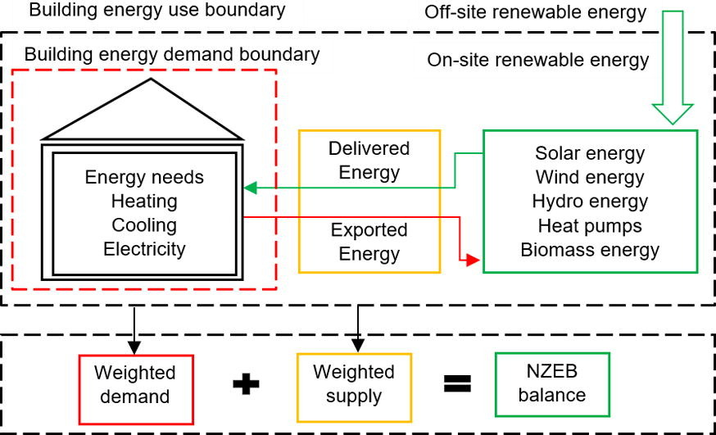
Figure 1: Conceptual diagram of Net Zero Energy Buildings (NZEBs), illustrating energy demand, delivered and exported energy, and renewable supply (on-site/off-site). NZEB balance is achieved when weighted supply equals weighted demand.

- TECHNICAL KNOWLEDGE

Phases of implementation
P1 | Assessment and Planning: Understand building needs and site conditions to select the most suitable renewable systems
P1.1 |  |  | Site Analysis: Evaluate solar potential, wind exposure, geothermal feasibility, and energy consumption
P1.2 |  |  | Needs Identification: Define heating, cooling, electricity, and hot water demand
P1.3 |  |  | Feasibility Check: Confirm technical and economic viability, assess envelope performance.
P2 | System Design and Preparation: Convert planning into detailed design and layout.
P2.1 |  | Technology Selection: Choose suitable technologies
P2.2 |  | Layout Design: Define component positions
P2.3 |  | Grid and Control Setup: Plan electrical connections, backup options, and EMS integration
P3 | Implementation: Procure and install all components
P3.1 |  |  | Efficiency Works: Upgrade insulation, windows, lighting, HVAC
P3.2 |  |  | Renewable Installation: Install and commission RES
P3.3 |  |  | Storage and Smart Systems: Integrate batteries, thermal tanks, and digital control
P4 | Monitoring and Optimisation: Ensure system efficiency and reliability over time
P4.1 |  |  | Commissioning: Test systems and provide user training
P4.2 |  |  | Performance Tracking: Use smart tools to monitor energy flows and schedule maintenance

- KNOWLEDGE RECOMMENDATIONS
RECOMMENDATIONS
Do: Combine renewable systems with energy efficiency upgrades
Do: Apply for funding opportunities
Do: Involve end-users early, especially in residential retrofits or energy communities.

Avoid: Oversizing systems or combining incompatible technologies without proper integration planning.
Avoid: Implementing RES without upgrading the building envelope (e.g. insulation, windows, air tightness).
Challenges: High upfront costs, limited rooftop space, complex permitting, or low user awareness. Tailor strategies to the local context and involve all relevant stakeholders.

- SCORING
Difficulty level  ☼ ☼ ☼ ☼ ☼ | Cost of implementation  € € € € €
Environmental impact  ♠ ♠ ♠ ♠ ♠ | Social acceptance  ☺ ☺ ☺ ☺ ☺

- COMPLETE FACTSHEET
ENERGY  EFFICIENT  BUILDINGS | INTEGRATION OF RENEWABLES
DESCRIPTION
Technical description
Buildings consume a large share of energy; around 40% globally; and contribute to more than one-third of greenhouse gas emissions. Reducing this impact is possible by constructing or renovating buildings to use less energy and by supplying that energy from renewable sources such as sunlight, wind, or geothermal heat. A building that produces as much energy as it consumes is known as a Zero-Energy Building (ZEB).

ZERO-ENERGY BUILDING: The core idea behind Zero Energy Buildings is to meet energy needs using renewable sources. These include solar, wind, geothermal, hydropower, hydrogen, and biomass. These systems reduce pollution and lower dependence on fossil fuels like oil, gas, and coal. The clean energy produced can be used for electricity, heating and cooling, hot water, and even transport.

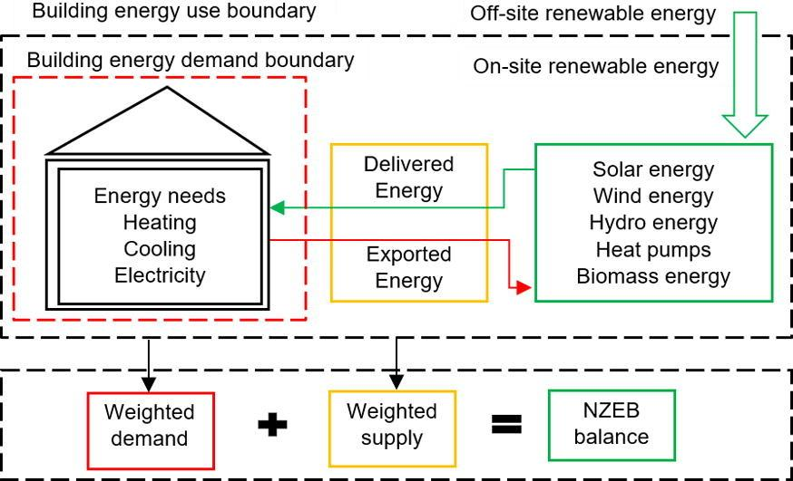
Ilustración 1: illustrates a two-way grid, capable of delivering energy to a building and receiving energy back from it. The red arrow in the diagram indicates exported energy, whether from on-site or off-site generation.
HEATING, COOLING AND HOT WATER:

- Solar thermal panels use solar radiation to heat water. Production varies by region. These systems are typically installed on rooftops or building façades. Simulations have shown solar coverage of up to 97% in summer and 62% in winter for domestic hot water (DHW). DHW systems can save up to 1459 kWh per year with payback periods between 6 and 10 years. They are often more efficient than PV systems (up to 70%) and work well when combined with thermal storage.

- Heat pumps transfer heat from air, ground, or water to buildings. They operate with low electricity use, delivering 3 to 5 times more heat than the electricity they consume (COP = 3–5). Types include air-source, ground-source, and water-source heat pumps. These systems also provide cooling. They integrate well with thermal or electrical storage, and they are suitable for ZEBs, district energy systems, Positive Energy Districts (PEDs), and energy communities.

  - Geothermal systems harness stable underground temperatures. It is the most efficient solutions when paired with heat pumps. Two main installation methods:
Closed loop: vertical (better for space-saving and hot water) or horizontal
Open loop: uses naturally stored water
These systems deliver 3–4 times more heat than the electricity consumed and are more sustainable when powered by renewable electricity.
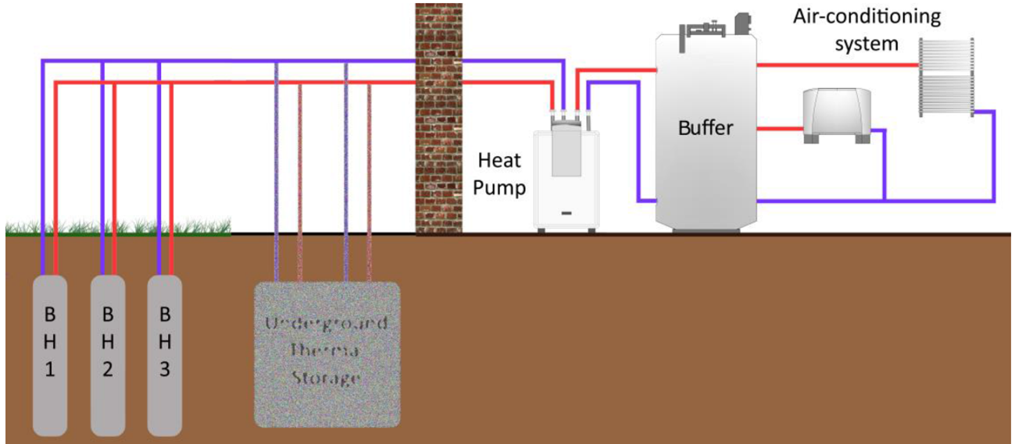
Ilustración 2: Schematic of a ground-source heat pump system with vertical boreholes (BH1-BH3), underground thermal storage, heat pump, buffer tank, and air-conditioning system.
  - Air-source heat pumps (ASHPs) can be air-to-water (for central heating) or air-to-air (for space heating). Their efficiency depends on outdoor temperature and compatibility with low-temperature emitters; otherwise, electricity consumption rises sharply.

ELECTRICITY PRODUCTION:

- Photovoltaic (PV) panels convert sunlight into electricity. Their output depends on solar radiation levels. PV systems have reached efficiencies of up to 46%, up from just 1% in earlier versions. In places like Hong Kong, rooftop PV systems have Energy Yield Ratios (EYR) of 10 to 15.8, meaning they produce 10–15 times the energy invested in their lifecycle.

- BIPV (Building-Integrated PV) systems are embedded into the building envelope; windows, façades, or balconies; generating electricity without requiring extra space. Although façades receive less sunlight, integration with passive or active cooling techniques (e.g., phase change materials) can double the annual solar potential.

- PVT (Photovoltaic-Thermal) systems produce electricity and heat simultaneously. These systems are more efficient than regular PV, achieving up to 43% higher electrical efficiency. Optimised systems can cover up to 51% of annual energy demand and 36% of DHW needs.

HYBRID SYSTEMS:
Hybrid renewable energy systems combine at least two sources of renewable energy. They also integrate generation and storage.Some examples:

- PVT systems: Cover up to 71% of DHW needs and 78% of electricity demand for appliances.

- BIPV systems: Double the surface area available for solar capture and enhance building performance

OTHER RENEWABLE OPTIONS

- Wind Power: Wind, caused by atmospheric pressure differences, can generate electricity using wind turbines.

  - Small wind turbines (e.g., 1.5 kW) installed on rooftops can supply over half a home’s electricity annually. Vertical-axis turbines are quieter, work at lower wind speeds, and need less maintenance. They are ideal for urban environments.
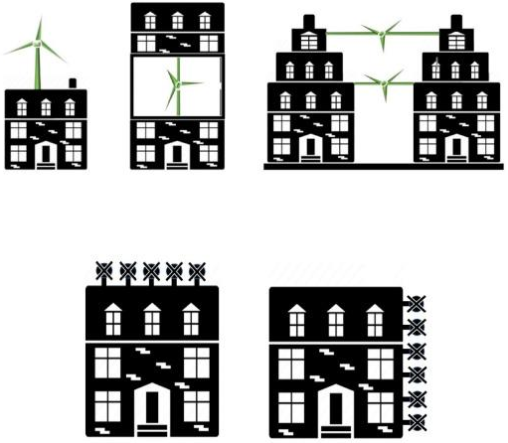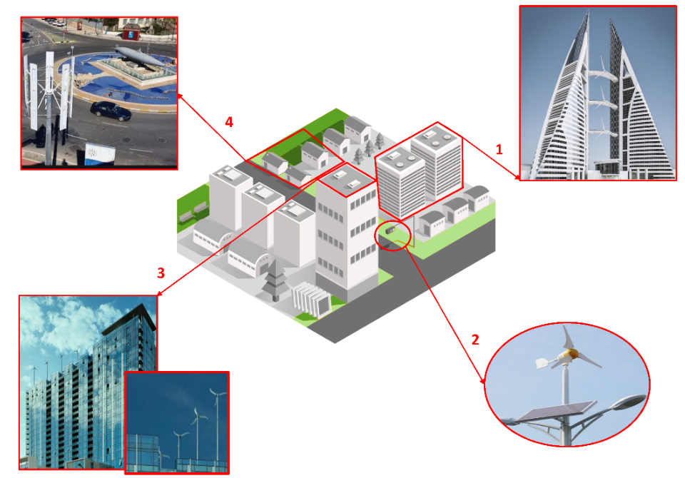
Ilustración 3: Urban wind energy integration options: schematic overview of possible placements of vertical and horizontal axis wind turbines on rooftops and façades, with real-life examples. Applications include residential buildings, public infrastructure, and land
Studies show that small wind turbines (1.5 kW) can produce 2541 kWh/year, covering 55% of annual electricity use, with a 26.8-year payback and CO₂ savings of 1093 kg/year. Vertical turbines are more efficient (>70%) than horizontal ones (50–60%).

Good practice: Bahrain World Trade Center uses horizontal turbines to cover 11–15% of energy demand

• Energy from solid waste: Provides both waste management and renewable energy. It can supply 20–23% of electricity and 4–5% of heating demand.

  - Biomass Uses organic material (wood, agricultural waste) for heat and power. Biomass accounts for around 9% of global primary energy. It emits up to 10 times less CO₂/MWh than fossil fuels, although it can increase fine particles in urban areas.

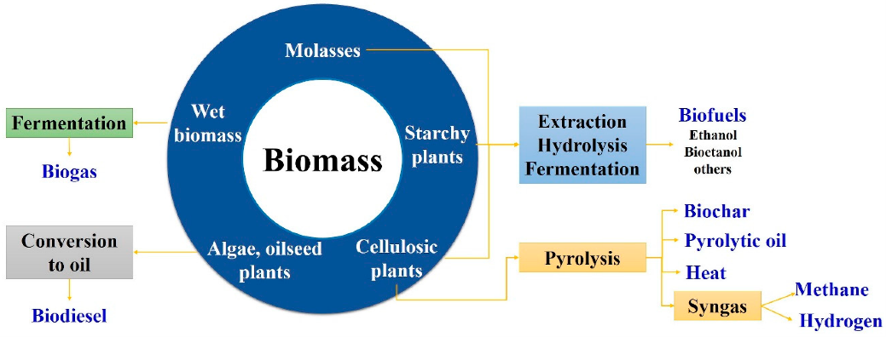
Ilustración 4:Biomass conversion routes into various biofuels through fermentation, oil extraction, and pyrolysis.

  - Biogas Produced from food or animal waste. A 9.5 m³ household system can deliver 5 hours of daily cooking. Combined systems for heating, cooling, and electricity can reduce CO₂ emissions by 94% and primary energy use by 32%, with average efficiency reaching 151%.
Challenges:
- Reduced efficiency in high ambient temperatures
- Limited technical knowledge and risk of system overload
- Requires good design, robust materials, and regular maintenance

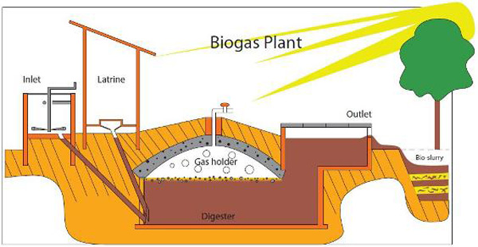
Ilustración 5: Cross-section of a biogas plant showing waste input, anaerobic digestion, gas storage, and slurry output.
• Hydropower Hydropower from small rivers can also be used in buildings, especially in places where water flows naturally. In 2021, 4400 TWh were generated from hydropower in large dams, 1.6 times more than nuclear power.

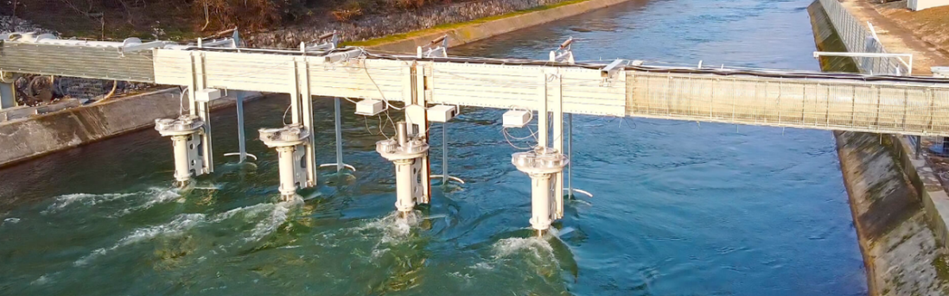
Ilustración 6: Small-scale hydro installation with submerged turbines in a canal flow system.
Building scale: Pumped hydro storage (PHS) elevates water to rooftops during low demand, then releases it to generate electricity. Requires structures to support 2 kN/m² and uses rainwater or mains supply. Simulations across 15 buildings show an average of 6 kWh/day generation, covering 70–80% of daily needs.

ENERGY STORAGE:
Energy storage systems help manage surplus renewable production, improve self-consumption, and balance supply. Types:
- Thermal storage conserves heat or cold for later use. This type of storage can store heat or cold for later use under varying conditions such as temperature, location, time or power.
- Batteries store electricity for use when the sun or wind are not available and allow stabilisation of the intermittency of renewable sources.
- Chemical storage, Hydrogen is also used in some places as a stationary storage method for both buildings and vehicles.

ENERGY COMMUNITIES:
Energy communities are legal entities where citizens, local authorities, or organisations collaborate to generate, manage, store, and share energy. Their goal is to create social, environmental, and economic benefits beyond profit.

These communities often use smart systems to track and optimise energy use. Storage (batteries, thermal systems, electric vehicles) helps deal with intermittency and guarantee supply.

Common activities:
- Generate renewable energy
- Provide energy efficiency services
- Share surplus energy
- Reduce energy bills

NEW IDEAS: DATA CENTRE HEAT: Some new systems take the heat from data centres (places where computers are working all day) and use it to warm homes or buildings nearby. This is a smart way to use energy that would normally be wasted, Producing, supplying, consuming, storing, and distributing potentially clean energy and Providing electric mobility or other energy services.

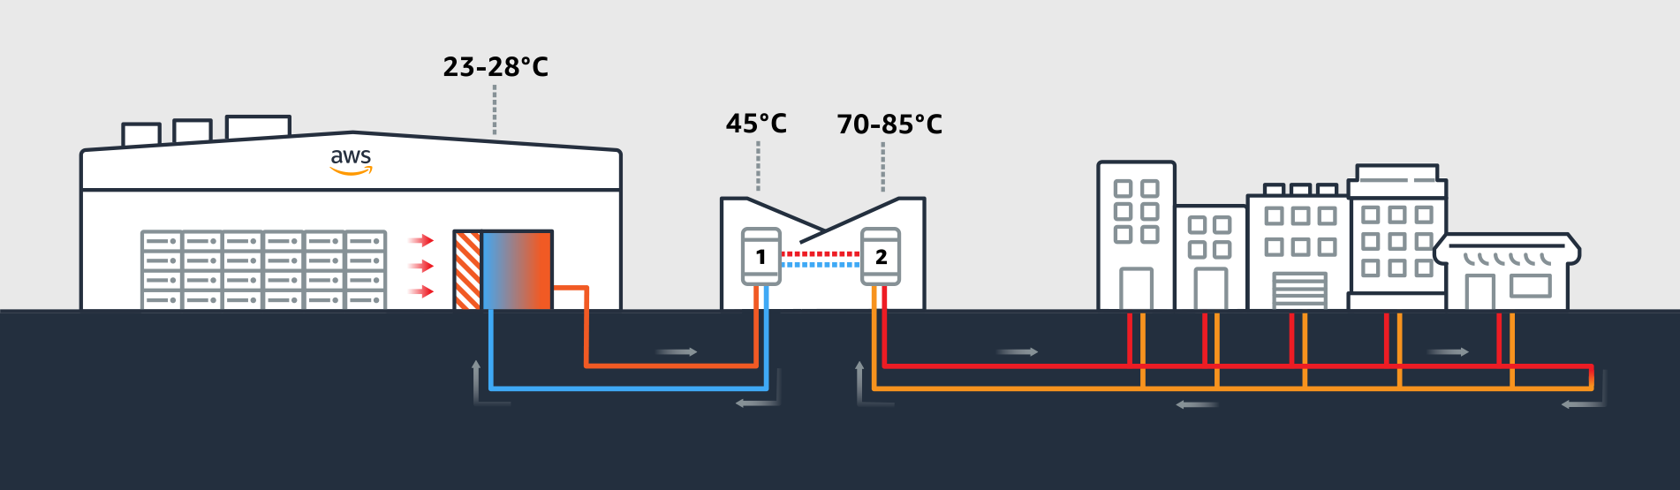
Ilustración 7: Waste heat from a data centre is recovered and upgraded to supply district heating networks.
SCORING
Technical Scoring
The technical complexity of integrating renewable energy technologies into buildings is medium to high, depending on the type and combination of systems selected.

- Low to moderate complexity systems include solar photovoltaic (PV) panels, solar thermal collectors, and air-to-water heat pumps. These are well-standardised in the market, with mature technologies, extensive installer networks, and proven performance in urban contexts. Their implementation typically involves limited structural modifications and can be executed under standard building permits.
- High-complexity systems such as photovoltaic-thermal (PVT) panels, building-integrated photovoltaics (BIPV), vertical geothermal loops, micro wind turbines, and hydrogen-based chemical storage demand advanced engineering design, structural assessment, custom integration, and interaction with digital control platforms like Energy Management Systems (EMS).
- Hybrid systems and energy communities introduce additional layers of technical sophistication. These include the need for interoperable components, demand-side flexibility strategies, Internet of Things (IoT) connectivity, and real-time energy monitoring and balancing.
Finance Scoring
- High initial capital expenditure, particularly for comprehensive retrofits, hybrid systems, or deep renovations involving multiple renewable technologies.
- Low operational and maintenance costs, once systems are in place. Solar thermal, heat pumps, and PV have minimal running expenses, especially when maintenance contracts and warranties are established upfront.
- Payback periods vary widely: solar thermal can achieve returns in 6–10 years, while small wind turbines and hydrogen systems may exceed 20–25 years, depending on local conditions and energy prices.
- Public and private funding mechanisms, can significantly improve financial viability, especially for public buildings and social housing.Co-benefits include:
  - Local economic stimulation through green jobs in construction, installation, and maintenance.
  - Energy security via increased self-generation, peak demand reduction, and enhanced resilience of buildings and districts.
Enviroment Scoring
- Net-zero energy buildings (NZEBs) cut CO₂ emissions, reduce primary energy demand, and favour the production of clean, decentralised energy. EU targets EPBD and Fit for 55 package.
- Improved air quality, particularly in urban areas, results from reduced use of fossil fuels and, cutting CO₂ and local pollutants (NOₓ, PM₂.₅).
- Bioenergy and waste-to-energy systems enhance resource efficiency and circularity by converting organic or municipal waste into useful energy forms (reducing landfill use and methane emissions).
- Efficient energy storage and smart management also limit of renewable electricity, ensuring optimal use of clean energy.
Social Scoring
- High acceptance is driven by visible and tangible benefits: improved indoor comfort, reduced energy bills and healthier environments.
- NZEBs and renewable buildings can significantly reduce energy poverty, particularly when applied in social housing or vulnerable neighbourhoods.
- Job creation and upskilling in the local economy enhance social value.
- Energy communities and participatory retrofits strengthen social cohesion, empower citizens, and increase collective climate action awareness. However, success depends on transparent communication, inclusive governance, and co-design with residents.
CONTEXTUAL BACKGROUND
Recurrent risks
- Poor building insulation or outdated energy systems
- Limited rooftop space or low solar/wind potential
- High initial investment costs or limited access to financing system
- Low user awareness and poor maintenance
- Structural constraints for installing renewable systems
- Complex or unclear permitting processes
- Obsolete technologies with high energy consumption
- Low citizen participation in planning or implementation
- Weak coordination across municipal departments or Misalignment between national and local regulations

- TECHNICAL KNOWLEDGE
Phases of implementation
P1 | Assessment and Planning
Preliminary phase to evaluate the site, contextual conditions, and technical feasibility of integrating renewables and efficiency measures
P1.1 |  | Site Assessment
 |  | Evaluate local renewable energy potential, such us solar irradiance, wind speeds…
P1.2 |  | Needs Identification
 |  | Quantify energy consumption by end use. Identify loads and peak demand profiles. Align demand with the most suitable renewable technologies.
P1.3 |  | Feasibility Analysis
 |  | Assess technical and economic viability (Include preliminary system, envelope performance, and regulatory compliance.
P2 | System Design and Selection
Translate assessment into system specifications. Implementation time depending on building complexity and technologies involved
P2.1 |  | Technology Selection and Sizing
 |  | Choose technologies based on site conditions and demand. Dimension systems and ensure compatibility with HVAC and envelope interventions.
P2.2 |  | Integration and Layout Design
 |  | Design system layout, such us panel orientation, wind turbine mounting, heat pump loop depth among others.
P2.3 |  | Grid and Control Strategy
 |  | Define grid connection, battery backup, and smart controls.
P3 | Implementation
Procurement, installation, and commissioning
P3.1 |  | Energy efficiency works
 |  | Upgrade envelope, HVAC, lighting (LED), and airtightness
P3.2 |  | Renewable systems installation
 |  | Install selected RES
P3.3 |  | Storage and smart systems
 |  | Add storage, electrical batteries, and EMS. Integrate with smart meters and occupant interfaces.
P4 | Monitoring and Maintenance
Long-term phase for optimisation and reliability. Continuous process starting at commissioning.
P4.1 |  | System testing and commissioning
 |  | Check that all systems are installed correctly and working safely (inverters, batteries, heat pumps). Ensure connection with energy management systems (EMS) and provide user manuals and basic training.
P4.2 |  | Ongoing monitoring and servicing:
 |  | Monitor system performance using digital tools. Schedule regular maintenance and adjust settings to improve efficiency.

- GANTT
 |  |  | M  1 | M  2 | M  3 | M  4 | M  5 | M  6 | M  7 | M  8 | M  9 | M  10 | M  11 | M  12 | M  13 | M  14 | M  15 | M  16 | M  17 | M  18
P1 | Assessment and Planning
P.1.1 |  | Site Assessment
P.1.2 |  | Needs Identification
P.1.3 |  | Feasibility Analysis
P2 | System Design and Selection
P.2.1 |  | Technology Selection and Sizing
P.2.2 |  | Integration and Layout Design
P.2.3 |  | Grid and Control Strategy
P3 | Implementation
P.3.1 |  | Energy efficiency works
P.3.2 |  | Renewable systems installation
P.3.3 |  | Storage and smart systems
P4 | Monitoring
P.4.1 |  | System testing and commissioning
P.4.2 |  | Ongoing monitoring and servicing

- STRATEGIC
RECOMMENDATIONS
DOs | - Start with a detailed energy audit  - Apply for EU or national grants  - Combine renewables with insulation and storage  - Use smart systems to improve performance  - Involve users early and offer training | DON’Ts | - Don’t skip the design phase  - Avoid overcomplicated systems with high maintenance  - Don’t ignore visual impact in sensitive areas  - Don’t forget to plan for regular maintenance or help for users  - Don’t think it’s just about the technology; people need to understand and accept the changes

- CROSS-LINK MATRIX BETWEEN TECHNICAL ACTIONS
Main Topic ↓ Related → | PV PANELS | THERMAL PANELS | GEOTHERMAL | BIOMASS | ENERGY COMMUNITIES
PV PANELS |  | C  Complementary | S  Synergy | S  Synergy | S  Synergy
PV PANELS |  | Can support domestic hot water needs when solar thermal is insufficient. | PV supplies electricity for heat pump operation in geothermal systems. | PV provides electricity while biomass covers thermal loads, balancing energy profiles. | PV enables self-consumption schemes in energy communities.
THERMAL PANELS | C  Complementary |  | S  Synergy | S  Synergy | R  Related
THERMAL PANELS | Can complement PV for full building energy coverage (electric + thermal). |  | Efficient when used for DHW in summer, while geothermal covers winter demand. | Thermal panels can operate in summer, biomass in winter for balanced DHW and heating. | Can be integrated in energy communities to supply hot water via shared networks.
GEOTHERMAL | S  Synergy | S  Synergy |  | C  Complementary | R  Related
GEOTHERMAL | PV powers heat pumps used in geothermal systems. | Thermal panels cover part of DHW demand, geothermal supplies heating/cooling. |  | Can coexist by covering different demand profiles (e.g. peak vs base load). | Useful in collective heating/cooling systems within energy communities.
BIOMASS | C  Complementary | S  Synergy | C  Complementary |  | R  Related
BIOMASS | Complements PV by supplying thermal energy in low-sunlight periods. | Combines well with thermal panels seasonally (biomass in winter, thermal in summer). | May be used in parallel where heating demand is high. |  | Applicable in rural or forested communities for local heat generation.
ENERGY COMMUNITIES | S  Synergy | C  Complementary | R  Related | R  Related
ENERGY COMMUNITIES | PV is often the core of self-consumption and shared electricity models. | Thermal panels can feed shared DHW systems in multi-building networks. | Geothermal can power district-level heating and cooling in energy communities. | Biomass provides renewable heat within energy communities, especially in rural areas.

- POLICY FRAMEWORK

Relevant Policies
International level
- UN Sustainable Development Goals (SDGs)
  - Goal 7: Affordable and Clean Energy
  - Goal 11: Sustainable Cities and Communities
  - Goal 13: Climate Action
*NZEBs contribute to these goals by improving energy efficiency, reducing emissions, and enhancing building resilience.

- Paris Agreement and COP Climate Targets: NZEBs support countries’ Nationally Determined Contributions (NDCs) by cutting emissions from the building sector.

- UN-Habitat’s New Urban Agenda: This agenda encourages sustainable, inclusive, and energy-efficient urban development.

- Resilient Cities Network: It promotes urban strategies that include energy resilience, with NZEBs as a key component of climate adaptation.

European level
- European Green Deal: This deal sets the EU’s roadmap for climate neutrality by 2050. NZEBs are central to reducing building-sector emissions and boosting sustainable renovation

- New European Bauhaus: It promotes sustainable, inclusive, and aesthetically high-quality built environments

- Energy Performance of Buildings Directive (EPBD): This directive requires all new buildings to be NZEBs and promotes deep renovation of existing stock.

- Renovation Wave: This initiative aims to double renovation rates and reduce energy poverty by upgrading the building stock across Europe.

- Fit for 55 Package: It establishes targets for at least 55% GHG reduction by 2030.

- REPowerEU: This plan accelerates clean energy deployment at all scales, including building-level renewables.

- EU Climate Adaptation Strategy, Circular Economy Action Plan, and Digital Europe Programme: These initiatives support sustainable building solutions, efficient resource use, and digital innovation (Monitoring and control).

- Covenant of Mayors for Climate and Energy: This supports local governments in aligning their actions with EU climate and energy targets.

- Smart Cities Marketplace / Clean Energy for EU Islands / Energy Poverty Advisory Hub: These platforms provide technical, financial, and governance tools to facilitate the implementation of energy-efficient, renewable-powered buildings.

National level
- National Energy and Climate Plans (NECPs): These plans spell out how each country aims to hit the EU's energy and climate targets. Often, Nearly Zero-Energy Buildings (NZEBs) are a big part of cutting down emissions from homes and public buildings.
- Recovery and Resilience Plans: These plans get money from the EU to help countries recover green after COVID. Many national plans set aside a lot of cash for fixing up old buildings to make them NZEBs and for putting renewables into them.
- National Building Codes: These rules for building are often updated to make sure new buildings are much more energy-efficient and use renewable energy, following the Energy Performance of Buildings Directive (EPBD).
- Climate Adaptation Plans, Urban Agendas, Smart City strategies, Sustainable Mobility Plans, Circular Economy roadmaps, national Green Deals, specific climate laws, and funding programs like the NextGenerationEU recovery funds.
Local level
- Local Climate and Energy Plans (SECAPs or PACES): Local governments often make climate plans that include renovating municipal buildings to NZEB level, especially schools, libraries, or housing for low-income families.

- Local Urban Agendas (e.g. Agenda 21): These focus on sustainable neighbourhoods and support better energy use in homes and public buildings.

- Housing Renewal Plans: Aim to upgrade old buildings. They combine energy efficiency with better living conditions, especially for vulnerable groups

- Smart City Strategies: Help cities use technology to reduce energy consumption, improve lighting and heating, and monitor energy use in real time.

- Sustainable Mobility and Green Infrastructure Plans: Even though they are focused on transport and nature, they are often connected to clean energy and better buildings.

- City-specific strategies: Some cities create their own local energy or renovation strategies. These may include solar roofs, heat networks, building retrofits, or rules for new buildings to follow NZEB standards.

- STAKEHOLDER ROLES AND ENGAGEMENT FRAMEWORK
Stakeholder | Role | Type of Collaboration
MUNICIPALITY | Permits, planning and gants | Regulatory / Financial
BUILDING OWNERS | Investment and decision making | Financial / Operational
USERS | Daily operation and behaviours | Social / Practical
DESIGNERS | Energy audit and system design | Advisory / Technical
INSTALLERS | Renewable setup and upgrades | Technical
ENERGY AGENCIES | Provide expertise, tools, and data to help define energy-efficient solutions | Technical / Advisory
LOCAL BUSINESSES | Supply materials, technologies, or services; may benefit from local jobs. | Economic / Technical
COMMUNITY GROUPS | Awareness and support | Social / Engagement

- MAIN REFERENCEs
GOOD PRACTICES / SOME EXAMPLES
Project
Project name: RENERMap
Location: Europe
Description: Decision-support tool that maps and assesses renewable energy potential in the built environment to support NZEB planning.
Link: RENERMap Project – CARTIF

Project name: LOCALRES
Location: Europe
Description: Empowers citizens and local authorities to form renewable energy communities, integrating local RES generation and smart management.
Link: LOCALRES Project – CARTIF

Project name: ENFLATE
Location: Europe
Description: Uses digital tools to make energy consumption more flexible and integrates prosumers into the energy market, contributing to NZEB models.
Link: ENFLATE Project – CARTIF

Project name: METABUILD
Location: Europe
Description: Demonstrates how to optimise building performance and life-cycle sustainability using digital twin and multi-energy models.
Link: METABUILD Project – CARTIF

Project name: CITYfied
Location: Several EU countries
Description: Aims to develop replicable, systemic strategies for retrofitting urban districts into smart, low-carbon, NZEB areas.
Link: CITYfied Project – CARTIF

Web-site
Website: BUILD UP – The European Portal for Energy Efficiency in Buildings
Link: https://build-up.ec.europa.eu/
Description: This portal offers extensive resources, case studies, news, and technical guidance on energy efficiency in buildings, including NZEBs and renovation strategies across Europe.

Website: NetZeroCities Knowledge Repository
Link: https://netzerocities.app/knowledge
Description: A resource hub providing tools, case studies, and guidance to support cities in achieving climate neutrality.

Website: BUILD UP_ The European Portal for Energy Efficiency in Buildings
Link: https://build-up.ec.europa.eu
Description: Offers high-quality resources, technical reports, news, and case studies on building renovation, NZEBs, and EU energy policies.

Paper
Paper title: Assessment of the renewable energy generation towards net-zero energy buildings: A review
Authors: Asam Ahmed, Tianshu Ge, Jinqing Peng, Wei-Cheng Yan, Boon Tuan Tee, Siming You
Journal: Energy and Buildings
DOI or link: https://doi.org/10.1016/j.enbuild.2021.111755

Paper title: Renewable energy potential towards attainment of net-zero energy buildings status – A critical review
Authors: S. Christopher, M.P. Vikram, Chirodeep Bakli, Amrit Kumar Thakur, Y. Ma, Zhenjun Ma, Huijin Xu, Pinar Mert Cuce, Erdem Cuce, Punit Singh
Journal: Journal of Cleaner Production
DOI or link: https://doi.org/10.1016/j.jclepro.2023.136942

Paper title: An Overview on Functional Integration of Hybrid Renewable Energy Systems in Multi-Energy Buildings
Authors: L. Canale, A.R. Di Fazio, M. Russo, A. Frattolillo
Journal: Energies
DOI or link: https://doi.org/10.3390/en14175520

Paper title: Energy communities—lessons learnt, challenges, and policy recommendations
Authors: L. Neij, J. Palm, H. Busch, T. Bauwens, S. Becker, A. Bergek, A. Buzogány, C. Candelise, F. Coenen, P. Devine-Wright, et al.
Journal: Oxford Open Energy, Volume 4, 2025
DOI or link: https://doi.org/10.1093/ooenergy/oiaf002

Paper title: Renewable energy communities for sustainable cities: Economic insights into subsidies, market dynamics and benefits distribution
Authors: Paolo Basilico, Alberto Biancardi, Idiano D'Adamo, Massimo Gastaldi, Tan Yigitcanlar
Journal: Applied Energy
DOI or link: https://doi.org/10.1016/j.apenergy.2025.125752

Paper title: Energy communities in social sciences: A bibliometric analysis and systematic literature review
Authors: Maksym Koltunov, Lorenzo De Vidovich
Journal: Renewable and Sustainable Energy Reviews
DOI or link: https://doi.org/10.1016/j.rser.2025.115871

Paper title: Solar Thermal Heating and Cooling: Technology Development Report
Authors: Carlsson J.
Journal: European Commission – Joint Research Centre
DOI or link: https://doi.org/10.2760/706387 (online)

- KEY CONSIDERATIONS
Additional Notes
- Energy Demand Reduction: Prioritize building design and renovation strategies that minimize energy consumption (insulation, passive design, and energy-efficient appliances).

- Renewable Energy Integration: Select and integrate appropriate renewable sources; solar (PV, BIPV, PVT), wind, geothermal, biomass, and hydropower; based on local resource availability and building characteristics.
- Lifecycle Assessment: Assess the environmental and economic impacts of renewable systems over their lifecycle, including payback periods, CO₂ savings, and maintenance requirements.
- Energy Communities and Smart Management: Explore participation in energy communities for shared generation, storage, and consumption, leveraging smart systems for optimization.

SUPERSHINE EXPERIENCE
* In this second phase, cities are invited to share brief feedback on their experience with the proposed solution. Please indicate whether the solution was implemented (Yes or No), explaining the reasons behind this choice. If implemented, summarise the process and key outcomes; if not, describe the main barriers. In all cases, include a short overview of your city’s context in relation to this type of technical action (e.g., political priorities, administrative capacity, infrastructure, citizen engagement, etc.). This information will help assess the feasibility and transferability of the solution across different urban contexts.
- TRIESTE
TRIESTE
Has this actions been implemented in your city?
Describe your city´s experience

- HERNING
HERNING
Has this actions been implemented in your city?
Describe your city´s experience

- RIGA
RIGA
Has this actions been implemented in your city?
Describe your city´s experience

- SETÚBAL
SETÚBAL
Has this actions been implemented in your city?
Describe your city´s experience

- BELGRADE
BELGRADE
Has this actions been implemented in your city?
Describe your city´s experience

- ZARAGOZA
ZARAGOZA
Has this actions been implemented in your city?
Describe your city´s experience

- KADIKOY
KADIKOY
Has this actions been implemented in your city?
Describe your city´s experience

